Group Policy Caching – Jon Misevicz.
Starting with Server 2012 R2 Standard, the ability to cache a group policy became an option. This option helps improve login times for computers because the group policy is stored locally on the computer.
After Group Policy caching is enabled, the next time the computer reboots it will download the most recent copy of the GP to the local computer store. When the computer logs in next it will retrieve that policy from the local store instead of the server.
To Configure Group Policy Caching.
- Open Group Policy Management.
- Expand the domain and right click on the GPO you wish to cache.
- Click Edit
- Expand Nodes Computer Configuration -> Policies -> Administrative Templates -> System -> Group Policy
- Double Click Configure Group Policy
- Select Disabled, or Enabled and click OK
- Close Editor
- Update GPO.
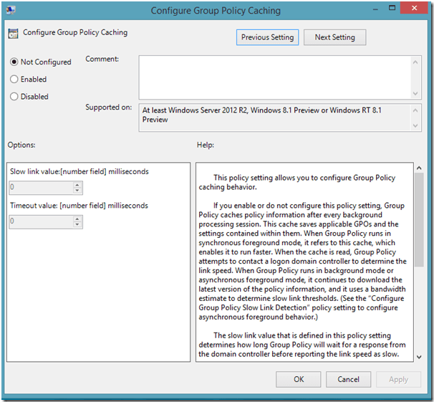
There have been some reports that Group Policy Caching causes an increase in login times on computers via wireless who are not connected to the domain. This issue appears to have been resolved with the Windows 8.1 Update.
From many forum discussions it has been adopted as best practice for servers but not for domain computers.

