The Future of Self Monitoring Health Devices
Framework Document

Jon Misevicz
2013

Contents
Definition 2
Information Sources 3
Experts 3
Texts 3
Periodicals 3
Smartphone Applications and Websites 4
Devices and Websites 4
Organizations 4
Current Conditions 5
Stakeholders 5
History 7
Trends 9
Baseline Forcast 11
Constants 11
Cycles 13
Trends 14
Projections 17
Expected Future 18
Alternate Future 19
Key Assumptions 19
Two by Two Planning Matrix 21
Alternative Futures 22

Definition

Health self-monitoring management used to be the realm of an educated few who knew how to understand readings taken from medical instruments and how to develop a health plan. The users involvement was little more than visiting a health professional, or knowledgeable professional at a gym, and trusting their plan. Now the industry is starting to twist and turn in ways that as little as 10 years ago wasn't even a consideration. The relative cheap nature and size of microprocessors has allowed them to be placed in an object no larger than an AAA battery while containing enough instruments to collect in real time everything from walking patterns, heart rate, blood sugar, and even sleep patterns. The age of personal responsibility over their medical information is coming of age, and with the next generations comfort with sharing information a veritable mountain of data is being generated which will give medical science an unprecedented sample of the populace.
This forecast focuses on the future of self-monitoring management in 2025 on the trend of allowing one's self's vitals to be monitored all the time, specifically when dealing with fitness levels and quantifiable biometric markers (blood sugar, heart rate etc. ). This does not venture far from the United States, and stays within what is considered reasonable home use products and products that will be carried personally, not administered by a medical professional. There are some serious concerns over the collection of data and what decisions can be made with such data but there are dedicated groups that are self-identified as Quantified Selves which use the power of data collection to find matching trends. The age trend seems to be the younger generations are more inclined to use such devices and are using available technology, (i.e. smart phones) to mimic what used to be expensive monitoring technology (i.e. Map My Run).
The onset of these self-collection devices is important because it allows a user to take control of their own health in a way that they have not been able to before. They are able to do analysis and capture data that once was only able to be accomplished by visiting your family doctor or by purchasing the expensive medical devices yourself. For research and the medical community, access to tens of thousands if not millions of data points which once would have to be hand collected and then entered into a database, is a dream come true and ripe for analysis.
To limit the scope of this examination there will be several factors which will not be taken into consideration. The pros and cons for health insurance will not be discussed, although mention of how the data may be used includes government and insurance references. Expensive and current medical grade technology which cannot be readily purchased will also not be included. The area of focus will be on information that can be digitally collected via a small personal device. Entering information into a website or other forms of manual data collection will not be included.

Information Sources

Experts
Gary Wolf
The founder of the web-site Quantified Self in 2008 which is a global collaboration site of users and makers of self-tracking tools, who has also written several books and for magazines. His New York Times article still remains the definition of this growing movement.
http://quantifiedself.com/
Christine Robins
The current CEO of Pittsburg-Based Body media, creators of the FIT Armband and the former President and CEO of Phillips Oral Healthcare Division.

Sonny Vu
The founder and CEO of Misfit Wearables, a hightly wearable sensor devices and medical applications. He formerly lead AgaMatrix, and developed the first iPhone connected bio-medical device which was a glucose meter. Winner of the Red Dot Design award.

Texts

Kaku, Michio - Physics of the Future: How Science will Shape Human Destiny and Our Daily Lives by the Year 2010, Double Day, 2011
Fascinating in-depth review of upcoming technologies and trends relating to computers, medical devices and communications, including interviews with current industry leaders.

Periodicals

User Centric
Future of Fitness: A Field Study on usability and personal activity monitors.
http://www.usercentric.com/news/2010/11/10/future-fitness-field-study-usability-and-personal-activity-monitors
Time Magazine
US Weekly Magazine devoted to trending topics in multiple genres.
http://techland.time.com/2012/08/06/the-future-of-smart-health/
Bio Medical Central
Public Health Medical Journal Website.
http://www.biomedcentral.com
Fitness Magazine
Magazine devoted to ongoing fitness trends and exercise routines.
http://www.fitnessmagazine.com/

Smartphone Applications and Websites

My Fitness Pal
A diet and fitness community with an application for smart-phones which allows users to scan a products UPC, and then uses a database to populate nutritional data. This site also has several already running links to popular activity trackers
http://www.myfitnesspal.com/

iFit
Fitness tracker website which has partnered with hardware manufacturers to include activity monitors in treadmills, exercise bikes and smart-phones.
https://www.ifit.com/

Map My Run
GPS enabled smart phone application and website which allows a user to track their outdoor running progress using the GPS. It also allows a user to pre-map runs and then track their progress on the preplanned route.
http://www.mapmyrun.com/

Cool Running
Fitness website featuring activity tracker enabled links to their popular Couch to 5 Kilometer program.
http://www.coolrunning.com/

Microsoft HealthVault
Cloud based service which offers several different programming links to popular self monitoring software for collecting all your information in one place.

Devices and Websites

Fitbit/Aria Scale
Wireless self monitoring tracker which monitors miles waked, flights of stairs, steps, sleep cycles and calories. The scale also records weight and body fat based on bare feet. The information is wireless and stored in a website.
http://www.fitbit.com/

Nike+ FuelBand
Water resistant wireless activity monitor which includes tracking for running, walking, basketball, dancing and other activities. Including calories burned.
http://www.nike.com/us/en_us/c/nikeplus-fuelband

Organizations

Center for Disease Control and Prevention
U.S. Federal agency that organizes, and creates expertise, information and tools that people and communities need to protect their health.
http://www.cdc.gov/

Consortia Advancing Standards in Research Administration Information
Non-profit standards development organization whose goal it so develop and maintain a common data dictionary for best practices for data exchange and reuse.
http://casrai.org/

Current Conditions

Current U.S. Health Situations according to CDC.
- 60% of Americans are not regularly active. 25% of Americans are not healthy at all.
- Studies show that support is greatly needed for a person to increase their physical activity, even a minor amount can contribute greatly.
- Repeated studies have shown that 30-45 minutes of physical activity is needed to show significant health improvements.
- Nearly half of all Americans 12-21 are not vigorously active, but the trend is shifting beyond the age of 21 toward exercise.
- Engaging young Americans, maybe through technology, can increase positive physical activity routines into adulthood.
Source: http://www.cdc.gov/nccdphp/sgr/pdf/execsumm.pdf
- Michio Kaku predicts that the cost of computer technology will decrease and it will eventually become nearly disposable. At this point consumers will see an increase of small objects which will be able to track all elements of their health. Eventually alerting doctors to health issues before we ourselves report any issue. Source: Physics of the Future

- By using a large data set, such a network could help scientists, policymakers and business people to take the knowledge that is now locked in scientific publications and create new technologies and applications
Source: http://phys.org/news/2012-10-web-based-datasets-huge-benefits.html#jCp

- According to CASRAI. There are three goals to providing a shared dataset of information
  - Save time for researches (applying and reporting)
  - Improve access to quality data for institutions and funders
  - Simplify the measurement of research impacts on society
Source: http://casrai.org/about

- Technological developments, particularly the internet, have made data sharing generally a trivial logistical problem.
Source: http://www.trialsjournal.com/content/7/1/15

Stakeholders

Consumer
The consumer for the first time has a wide array of technology at their fingertips which was until recently only in the purview of the technologically inclined or the medical community. The consumer is driving the purchase of self monitoring technology and providing their data within the terms and conditions of application use. The individual consumer is starting to gain the momentum to drive the direction of this technology with their wallets, and each step they take.

Medical Research
The large datasets that can be sold by the self-monitoring equipment developers is vast and complex. It has already been shown by companies such as Google and Facebook that data is a gold mine. By being able to analyze the physical activity that a person, by any number of variables can start to point out trends, which can and will guide medical research.

Quantified Self’s
The groups of dedicated consumers who mine their own data collected from devices, and then use the community to help find trends. This group is already starting to correlate connections that some in the medical community would have once called “Voodoo”. These type of open source communities will continue to grow and benefit from not having their health dictated from one source, but can tap into the collective for thousands of opinions.

Medical Device Manufactures (Fit Bit, Body Media, etc.)
With any small type of medical devices they will become so small they will become nearly disposable. As the technology becomes better some of the key players will become more specialized which will create more demand for the product. This could open up a whole new industry or augment current product catalogs.

Insurance Agencies
The medical insurance agency is the dark entity in the room which could use such data for good or bad. From their perspective it could be used to select those individuals which would be the lowest risk, and help them develop new algorithms that identify new risk categories.

History

History information regarding these devices is hard to come by as it is a relatively new area. Below is a summary of information based on various sources.

 | Pre 1990’s | 2013
Number of Steps | Manual Count or based on formula (Distance/Stride length). | Real-time based on average stride length for an adult American within height category.
Distance | Typically based on approximate total distance traveled or SWAG. | GPS tracked or tracked via a treadmill.
Sleep Pattern | Secondary person or medical facility needed | Real time based on reported bed and wake time.
Stairs | Physical count while performing activity | Real-time based on accelerometer and average 10 ft change in elevation.
Caloric Count | Estimate based on average food eaten, exercise. Time consuming and usually done with aid of a dietitian. | Can be nearly instant using food diaries that access bar-coded nutritional information and real-time exercise data. Formulas are a well guarded secret.
Heart Rate | Count pulses over course of 15-30 seconds and then multiply to get over a minute | Real time based on tracking monitor.
Time to compile | Could take hours daily to compile | Instant, wireless update to datacenter.

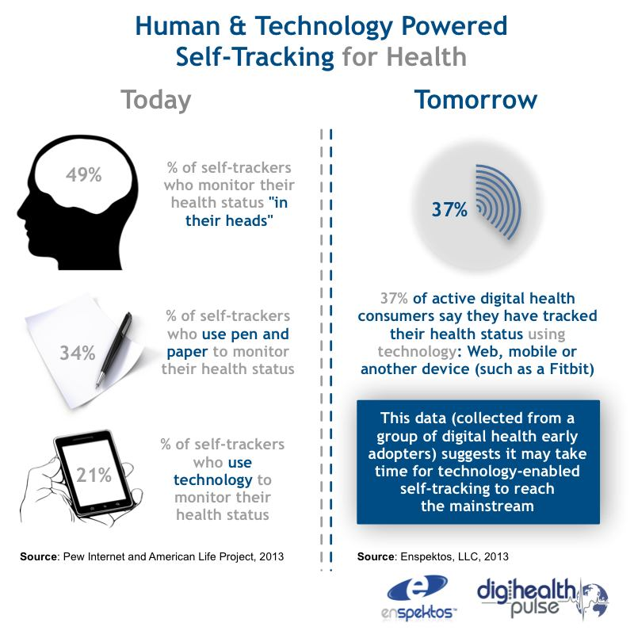Source: http://digihealthpulse.info/self-tracking-for-health-why-brains-will-continue-to-dominate-digital-for-the-immediate-future/
Summary
When comparing the table above you notice that there is a radical change in the way we can monitor our health. This current area is developing very rapidly that there are distinct changes in as little as 18 months. This growing field has yet to fully develop to give pattern as such it is hard to define a pattern of history as the ability to self-monitor one’s health was based on manual calculation, or guestimates. The impact of the technology is on the verge of starting a whole new trend cycle that hasn’t existed before. To go from nothing to having very accurate, self-reporting data collection devices is a sharp leap, not a gradual walk up a curve. The rapid pace of advancement in this area, in particular the crowd sourcing community, shows that there are radical changes in just as little as two years.

Trends

- Over the last 50 years in the U.S. we estimate that daily occupation-related energy expenditure has decreased by more than 100 calories, and this reduction in energy expenditure accounts for a significant portion of the increase in mean U.S. body weights for women and men. Source: http://www.plosone.org/article/info%3Adoi%2F10.1371%2Fjournal.pone.0019657

- ABI Research estimates that the total number of wearable devices with fitness and wellness applications will grow from 16.2 million in 2011 to 93 million in 2017. It also predicts that revenue from sports and wellness mobile apps will rise from $123 million in 2010 to $341 million in 2016

- It all starts with starting what is called "closing the loop" on capturing, analyzing and understanding everyday health.
Source: http://www.entrepreneur.com/article/223780#ixzz2Pp6p2m2Y

- Statistics show that almost 40% of all health apps downloaded are fitness-based
Source: http://www.tipsonhealthyliving.com/diet-and-fitness/the-top-5-health-and-fitness-trends-for-2013

- According to Abiresearch, they saw 38 percent of the smartphone downloaded apps were that of some type of health app and are predicting to see the fitness app market grow from $12 million in 2010 to $40 million by 2016. Therefore, over the next three years, we may see nearly a billion downloads. Depending on the effectiveness of these apps, we may also see doctors recommending apps to their patients.
Source: http://www.examiner.com/article/health-and-fitness-2013-trends-mobile-apps

- The ability to pull a minute by minute dataset using the FitBit Advanced Programming Interface is incredible. I was able to analyze a year's worth of data instantly.
Source: http://www.jamierubin.net/2013/03/20/one-full-year-of-fitbit-pedometer-data-part-1-a-look-back/

- 82% of all mobile owners share their personal information on their smart-phone in one way or another.

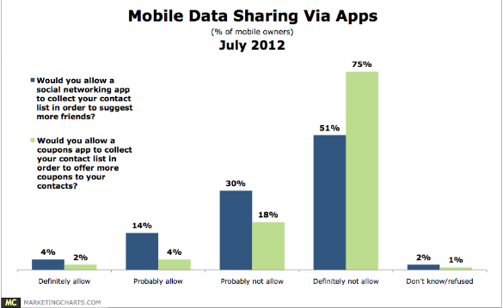 Source: http://www.marketingcharts.com/direct/mobile-owners-seen-reluctant-to-share-data-22662/

- Researcher's in particular often complain that they do not have enough data, but using a new data standard and infrastructure, the potential to overcome that problem is enormous and has the ability to transform the industry itself.
Source: http://phys.org/news/2012-10-web-based-datasets-huge-benefits.html

Baseline Forcast

Constants

- Moore’s law is an observation that over the history of computing hardware, the number of transistors on integrated circuits doubles approximately every two years. A 2010 update as to growth slowing at the end of 2013 after which time transistors counts and densities are to be double only every three years.
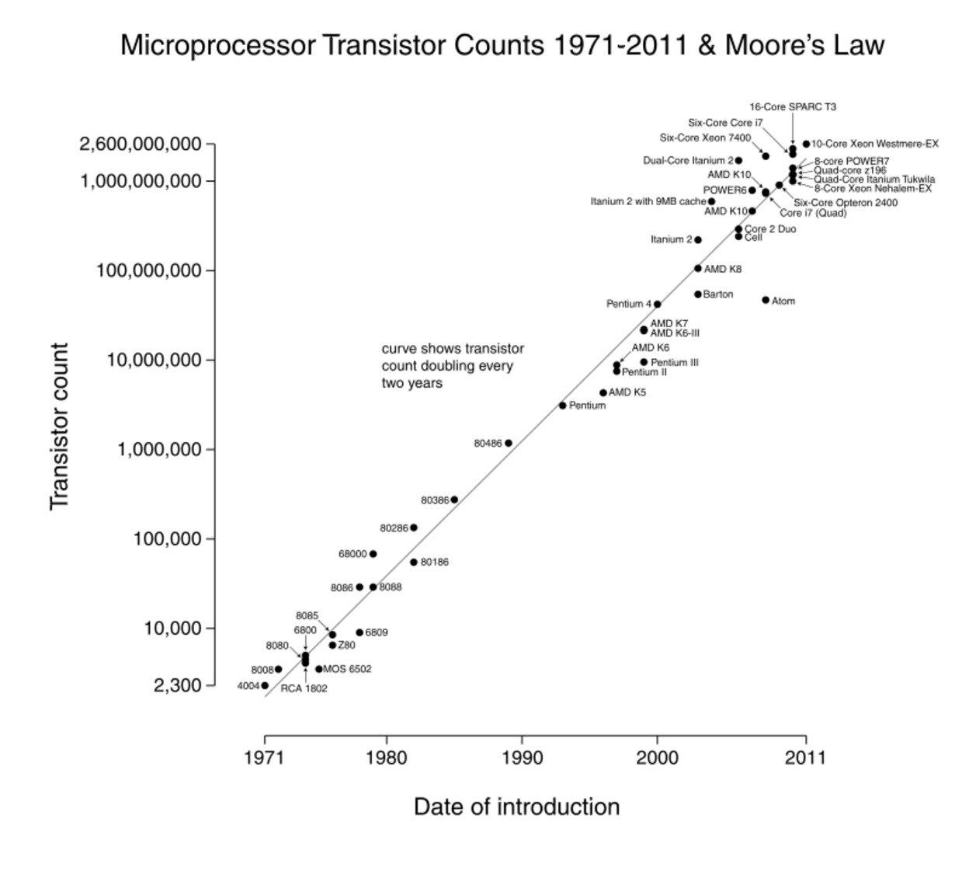
Source: http://en.wikipedia.org/wiki/Moore%27s_law
- Over the last decade, evidence of this rapidly evolving pattern is everywhere. “We have entered a period of history where digital technologies are driving massive disruption and incredibly rapid change in consumer behavior and expectation,” explains Jeremy Lockhorn. In particular, Lockhorn identifies the innovation of apps and the touch screen as the catalysts for the rapid speed increase in the Technology Adoption Lifecycle—a purchasing philosophy created in the 1950’s.
Source: http://blog.90octane.com/06132011/the-technology-adoption-lifecycle-how-consumers-are-driving-innovation-at-hyperspeed/

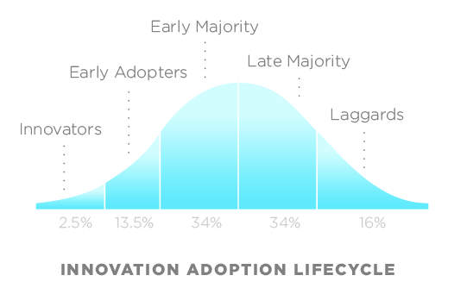
Source: http://en.wikipedia.org/wiki/File:DiffusionOfInnovation.png
- Numbers are making their way into the smallest crevices of our lives. We have pedometers in the soles of our shoes and phones that can post our location as we move around town. We can tweet what we eat into a database and subscribe to Web services that track our finances. There are sites and programs for monitoring mood, pain, blood sugar, blood pressure, heart rate, cognitive alacrity, menstruation, and prayers. Even sleep—a challenge to self-track, obviously, since you're unconscious—is yielding to the skill of the widget maker. With an accelerometer and some decent algorithms, you will soon be able to record your sleep patterns with technology that costs less than $100.
Source: http://www.wired.com/medtech/health/magazine/17-07/lbnp_knowthyself?currentPage=all

- Electronic self-trackers have no feelings. They are emotionally neutral, but this very fact makes them powerful mirrors of our own values and judgments. The objectivity of a machine can seem generous or merciless, tolerant or cruel. Designers of tracking systems are trying to finesse this ambivalence.
Source: http://thefloatinglibrary.com/2010/05/09/self-tracking-is-the-future/

Cycles

- Smartphone adoption is growing quickly, and health self-monitoring devices communities (Graph shows Nike-Plus Device) are showing a similar pattern of growth over the long term. The number of people using technology to track their health appears to be flat, and the total market for fitness tracking devices is tiny. The industry has some ideas on how to solve this mystery, but they would like to hear from the consumer in terms of sales before anyone makes a long-term commitment.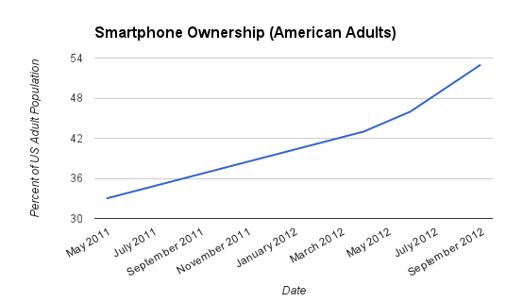
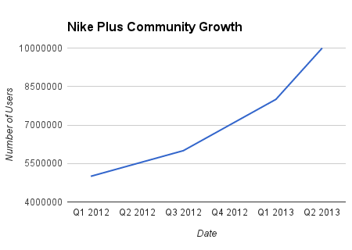
Source: http://quantifiedself.com/2013/01/how-many-people-self-track/
- "... new technologies make it simpler than ever to gather and analyze personal data. Sensors have shrunk and become cheaper. Accelerometers, which measure changes in direction and speed, used to cost hundreds of pounds but are now cheap and small enough to be routinely included in smartphones. This makes it much easier to take the quantitative methods used in science and business and apply them to the personal sphere."
Source: http://h30565.www3.hp.com/t5/Active-Information/Self-tracking-for-health-fun-and-profit/ba-p/1842

Trends
- “Seven in ten American adults are tracking health data, which sounds like a huge number until we follow up with the “gotcha” question of ‘How are you tracking? It turns out that half of trackers say they are keeping track of progress just in their heads. They don’t write it down, they don’t use a device, they don’t keep a spreadsheet. Half are just tracking in their heads. One in three say they are tracking on paper, like in a notebook or journal. One in five say they are using some form of technology, whether a medical device like a glucometer, or a website or a spreadsheet — any kind of technology.”
Source: http://mobihealthnews.com/20040/pew-most-us-adults-track-health-data-but-few-use-digital-tools/
Overview of Tracking
  - 69% of adults track a health indicator for themselves or others.
  - 34% of individuals who track use non-technological methods such as notebooks or journals.
  - 21% of individuals who track use at least one form of technology such as apps or devices.
The Impact of Tracking
  - 46% of trackers say that this activity has changed their overall approach to maintaining their health or the health of someone for whom they provide care.
  - 40% of trackers say it has led them to ask a doctor new questions or to get a second opinion from another doctor.
  - 34% of trackers say it has affected a decision about how to treat an illness or condition.
Tracking and Sharing
  - 34% of trackers share their data or notes with someone else.
  - 52% share with a health professional.
  - 22% share with a spouse/partner.

Source: http://www.pewinternet.org/~/media//Files/Reports/2013/PIP_TrackingforHealth_PDF.pdf

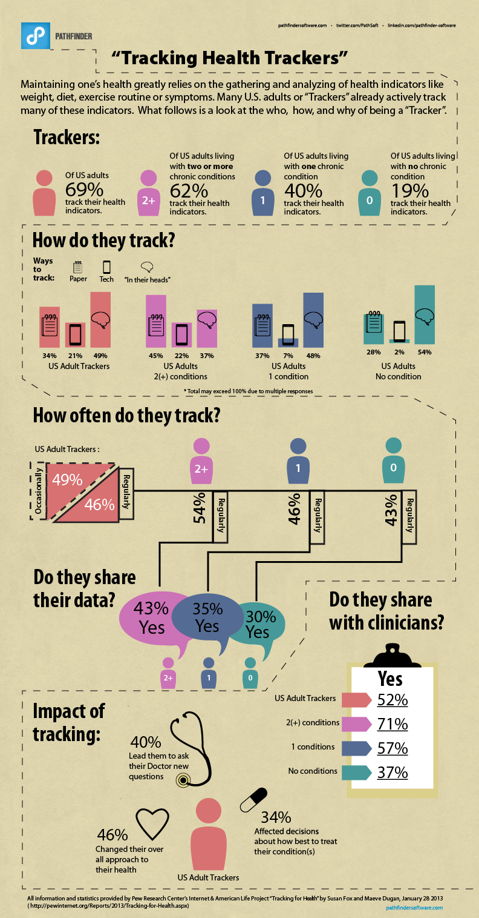
Source: http://www.hitconsultant.net/2013/04/17/infographic-the-impact-of-quantified-self-tracking/

- 34 percent say the practice affected a health decision, 40 percent say it led them to ask their doctor a new question or seek a second opinion, and 46 percent said it changed their overall approach to health.
Source: http://mobihealthnews.com/18911/pew-70-percent-are-self-trackers/

Projections

- Wearable computing devices are projected to explode in popularity over the next year and with a wave of new gadgets set to hit the consumer market, could soon become the norm for most people within five years. ABI Research forecasts the wearable computing device market will grow to 485 million annual device shipments by 2018.
Source: http://www.abiresearch.com/press/wearable-computing-devices-like-apples-iwatch-will

- Wolfram, the founder and CEO of Wolfram Research, thinks the data will eventually redefine what doctors do. A doctor would be hard-pressed to make sense of the data once people are wired to track their heart rate, blood sugar levels, blood pressure and dozens of other measures. But computers will be able to easily spot patterns and trends, diagnosing far more accurately than doctors can today, and far earlier in the disease process, says Wolfram, who is developing analytics to meet this need. He thinks that eventually we’ll go from sensor-based data to being able to treat whatever concern the technology diagnoses.
Source: http://www.bbc.com/future/story/20130102-self-track-route-to-a-better-life/2

- Amongst the many significant developments is a shift towards one-on-one, in-field diagnostics and monitoring. Services that were once only available at a doctor’s office or hospital are now available on-demand through low-tech, affordable solutions. Personal systems allow for ‘good enough’ diagnostics that would have been difficult, expensive, and timely to attain previously.
Source: http://www.psfk.com/publishing/future-of-health

- BodyMedia, says it’s working with insurance companies to get its self-trackers into more workplaces. FitBit is running an experiment with one insurer, to see if employees who use the devices go to the doctor less, something he describes as the “Holy Grail” for self-tracking products. “If we could make a direct connection to reduction in medical care costs, then I think the floodgates would be open,”
Source: http://blogs.kqed.org/stateofhealth/2012/12/20/self-tracking-movement-meets-subscription-model/

Expected Future

I roll over in my bed, which has been monitoring me along with a sensor near my nightstand and click the alarm off. It is 6:15 AM May 1st 2025 and before I even have my feet moved off the bed the activities of my night sleeping have already been uploaded to a server, and recorded. It has been indexed and regular sleep analysis has been performed within a few minutes. I start to head to the bathroom, the uploaded data has showed that I was tossing and turning in the night and having difficulty sleeping. When I step on my scale in the morning the weight, body fat, and several other metrics are taken and compared, noticing a weight gain over the last few months. The trend is matched with my difficulty sleeping.
A smart device triggers an alert and I read it, noticing the trend. The device outlays the pattern, and gives me suggestions based on others who have had trouble. Gives me an analysis that I might be developing sleep apnea and asks if I would like to send this data to my family physician for review, which I do. My regular meals are already uploaded into my smart device, a couple clicks and it gives me my total daily requirements, and remaining suggested intake. Before I leave for work I get a message from my doctor. No appointment needed currently if I start working out to lose weight. He has already gone through my past tracking data and noticed I haven’t been running as I once was, and gives me a recommended program which can be downloaded into the phone and/or my connected treadmill. He has also already updated a diet plan to help me get back down to a healthy weight based on previous history.
As I work though the day, a little tracker that has been linked up to sensors either on my body, or in small ingested microbots has been tallying my steps, blood pressure, breathing and uploading it to an offsite service for later analysis. When I get a meal at a fast food restaurant for lunch and enter it into my device I get a warning that this will not allow me to meet my goal and lose weight. This alert gives me pause to choose something else from the menu, which then meets the recommended diet plan.
On my way home I meet up with a group of friends who share their personal tracking, almost bragging about how far they went and percentage of body fat lost. It almost becomes a badge of honor to see who can achieve the most. One even says he has not gotten a reduction in his insurance for not meeting certain pre arraigned milestones and sharing his medical data. A female friend mentions that she had gotten a privacy alert to accept that her data be used in an upcoming study on working women in the city. She freely accepted and even authorized them to contact her for more personalized attention if they desired.
I skip out of the recommended running routine in the evening, and decided that I would be better served with a movie. I didn’t enter my popcorn into my device but the internal tracker has picked up the increase in salt levels and reported it to my device, which based on my previous acceptance of sharing my data has flagged my physician who will see it in the morning along with my lower than expected exercise level. I already have a matching alert in my messages for privacy concerns.
At home for the evening my smart devices calculates how long at my current activity level it would take to meet my goal, and recommends changes. I weigh myself again to record the measurements, and the process of analysis starts once again before I even lay my head down for an attempt at a good night sleep.

Alternate Future

Key Assumptions

There are three key assumptions that drive the core of the baseline forecast. Within the 10-15 year timeline the dramatic change in either of these will alter the outcome of this established baseline.
- Devices will continue to improve connectivity between tracker and online and assumes that they will eventually merge (as opposed to becoming disconnected).

- Consumers will continue the trend of opening up their private data to others (as opposed to becoming more guarded).

- Public policy will continue to protect individual user rights (as opposed to siding with private industry).
Key Uncertainties
- Anonymous data
  - Important: This topic is important because if a user can be identified by their data it could be used against them. Having the protection in place to not allow discrimination by private industry will allow consumers the freedom to share data without worry.
  - Uncertain: This topic is very much uncertain because of no legal precedent with current law. The trend with the current congress of the past 10 years has been to clamp down on sharing or to hold companies not liable for any discrimination caused by sharing of data. This has almost opened up a wild west of sorts as to who will blink first. Until this is tested in the courts there will continue to be uncertainty.

- Ease of Access
  - Important: The less a consumer or patient has to do to gather the data the better. Trends have shown that the more a person has to do to record their vitals the less the average person will do, in addition to making mistakes or ‘bending’ the truth a little bit
  - Uncertain: With competing devices using different technology there might not be enough consumers for early adoption to force a more mass market appeal. There are still the linking issues where a smart phone or wireless network is needed.

- Linking of Medical Records
  - Important: A complete record of vitals from one doctor to another would resolve the consumers need to allow access, carry records, and/or make a mistake and not provide the needed data to a specialist. The ability to do this already exists but current private industry is slow to open their business practices up to competitors.
  - Uncertain: The current debate at the federal level and taking place at states will hold back any linking of data until resolved, and is tested in the courts. No major hospital, insurance agency or smaller clinic is going to be the first unless there is a large number of competitors who go ‘All-In”.

Two by Two Planning Matrix

Research Nirvana  - Easy Access to consumer data  - Public Policy protecting Privacy  - Insurance and Business unable to use data to discriminate  - Private industry provides better, smaller devices, more services  - Medical Data freely shared between patient and doctor |  | Public System | Civil War  - Research stunted as incentive to share data becomes common  - Government takes no side, lawsuits set precedent.  - Marketing starts to drive innovation, how to gain access to more data  - Medical data still fragmented by stale public policy. No communication between patient and doctor on regular basis.
Smaller Device  Share Data |  |  |  | Smaller Device  Guard Data
Everyone Pays  - Public Policy protects the ability to use data to discriminate.  - Insurance industry uses open data to drop those who will cost the most.  - Research continues with public data but more private patents are created  - Hospitals begin to not admit people without tracking data, charging more |  |  | Patent Wars  - Private industry charges researches for access to data.  - Markets lock consumers into sharing data with their own company, then sell it.  - New insights are patented and then fought over in court.  - Innovation stagnates, infighting breaks down communities.
 |  | Private System

Alternative Futures

- Research Nirvana – Open access without paying the toll.
The year is 2025 and my smart devices rings from your friend with the latest discovery by a group in another country who raked open source data sets and found a correlation between specific cancers and a particular type of food. Your device records your latest statistics and sends them without your approval to your physician and then the government randomizes your identification and uploads it into a massive public research database.
Your recent purchase of an internal monitoring device is the latest trend, using the open technology the device has gotten down to the size of a grain of rice, and uploads on a wireless connection. When you go to the doctor for a checkup there is no need to authorize your data, he already has access to your records, past 5 years of history and has a couple interesting conclusions from the self-tracking community.
You can take those results and get the treatment without your insurance being able to charge you more because of the unhealthy lifestyle, or lack of some new key metric. You are continually targeted by marketing to update, get a new device, switch to this service to provide more insight but it is your choice what happens with your information.
- Civil War – consumers vs. privacy

It didn’t even seem like it happened, just slipped in to the rapid exchange of politics, another deadlock between the sides. This opened up a void where state courts started to decide privacy law. It didn’t take you any time at all, you doctor recommended a state of the art device that was marketed to him by the patent holder. It uploaded your data to a dataset but it required a few forms, one from your state, private law, one to share with your doctor it just seemed like too many steps.

You read on the local news as another university program had to close because the lack of data. You get a reminder to fill out your forms and you make the decision to allow your data, but only a little bit, not enough to really make a meaningful contribution but it makes you feel better. When you go to the doctor he asks you a couple questions and you openly question why he can’t just query the device he recommended. Apparently a new court decision has included another set of privacy agreements and since I never filled out the original ones it will require me to go through the process again. You question yourself on the way home and talk with my private group about my latest tracking results. The open community you used to belong to has disbanded when a law passed in the state where the server made it against the law to not encrypt the data which the owner couldn’t afford.

- Everyone Pays – Your own body betrays you.

You open a message from your employer who has made a suggestion to all employees to wear a self-tracking device. They offer no incentive to join the program and ask that you share the data with them. You don’t mind, as you have recently upgraded to the one you have and you know that you could get a poor review or even terminated for not following the suggestion. The ability to organize your vitals is good for your insurance, you are just a bit above average, have a healthier than average weight but recently you stopped walking as much. On your last paycheck your insurance increased a few cents.

The device you are given gives you many options, and services for you to use. You freely offer the data to a community and the creator of your device. The data is shared and used; you see your name appear on several studies where the device manufacture has sold your information to the university. You think it is alright, at least going to a better cause, to help find a cure. You visit your doctor and he says he can no longer help you as he cannot pay the access fee for your data from the manufacture. You say that you offered it up for free but he can be sued if he uses it for commercial purposes, and his insurance will not cover it. You are torn between the situations, and give your doctor a view of your vitals from your smart device.

- Patent Wars - “The first casualty when war comes is truth “ (Hiram Johnson)

You sit back for the day, checking your older tracking device. You read the bill you have gotten from the provider for privacy insurance to protect your data from being used for research, shared etc. As you look it over you’re reminded back about 15 years to the old cell phone plans, where you were locked into a device and plan for several years. You groan as it is harder and harder to get the service unless you upgrade and you opt for the lowest device that still qualifies for the mandatory tracking your company demands.

You pay the bill, knowing that the provider will still sell the data, but you hope that they will not know who you are. You watch the news, another battle in federal court on appeal as another patent fight over encryption this time, last week it was how the service looked, the week before it was the screens. You chuckle as the new devices haven’t changed all that much. Why change it if there is no incentive to buy? The business needs to milk each contract for as much as they can. You check your smart device, an arrest on copyright grounds where people where unlocking their devices, sharing the data instantly. If it wasn’t for the insurance companies keep requesting more information you wonder if these devices would even be updated with new metrics.

Scanning and Information Sources

Research Nirvana
- Quantified Self
  - http://quantifiedself.com/
  - Scroll though for the most up to date information on the community
  - Scanning hits from this source would give a good pulse on how the community is evolving and adapting to new rules/regulations. Currently has many different sections, meet up groups and quite active online community.
- Digihealth Pulse
  - http://digihealthpulse.info/
  - Click data streams in the upper right menu on the main page
  - Scanning hits gives an aggregate of many of the health stories being sourced from around the web. This being a new aggregator site it will link back to the original site for additional information.
- Mobihealth News.
  - http://mobihealthnews.com/
  - Updated feed on latest articles
  - Scanning the main page gives a good open sense of the mobile medical device field. It also links back to the researching sites where the article was created providing more additional scanning hits.
- Wired
  - http://www.wired.com/
  - News feed, Top stories
  - This is a very popular source for upcoming trends in the tech industry and has cross board memberships in many of the stake holder groups (Fitbit, Body Media). The topics vary and would be best to scan the Gear and Science categories.
Everyone Pays
- Digihealth Pulse
  - http://digihealthpulse.info/
  - Click data streams in the upper right menu on the main page
  - Scanning hits gives an aggregate of many of the health stories being sourced from around the web. This being a new aggregator site it will link back to the original site for additional information.
- Congress Bills and Resolutions
  - http://www.govtrack.us/congress/bills/
  - Chronological order of current bills.
  - Good main page to scan to learn what bills are currently up for vote, which ones are coming up to vote and who voted on which bills. Gives actual verbiage and detailed analysis provided by the government accountability office.
- Pew Internet
  - http://www.pewinternet.org/
  - Select topics and various categories.
  - Scanning this source provides current real poll data and analysis as to the current mood of the population or the direction current trends may be heading. Some scanning hits might be found by using the data tools feature.
- American Medical Association – Court Section
  - http://www.pewinternet.org/
  - New feed, top stories.
  - Scanning this resource gives a snapshot of all the current legislation that is relevant to the AMA’s docket, plus links back to the original site. Multiple scanning hits could be achieved by checking the resources on the left hand side.

